15 Awesome Google Search Tips and Tricks

http://www.thegeekstuff.com/2009/06/expertise-in-google-search/

You may be using Google search multiple times per day to locate something on the web. Learning how to use Google search effectively can boost your productivity instantly.  
   
This article is part of the on-going[Productivity Tips for Geeks](http://www.thegeekstuff.com/tag/productivity-tips-for-geeks/). In this article let us review 15 awesome google search tricks that will improve the quality of your online life.

**Note:** Also, check-out our earlier article about [15 Awesome Gmail Tips and Tricks](http://www.thegeekstuff.com/2009/07/best-gmail-tips-and-tricks/), and [15 Essential Gmail Lab Features](http://www.thegeekstuff.com/2009/08/15-essential-gmail-labs-feature/).

### 1. Identify Local Time for Any City in the World using Google

If you want to know current local time in a particular city, use the following method. To see the current local time in Los Angeles do the following. Go-ahead and try this yourself for your local city and see how it works.

Syntax: time in PLACE

[time Los Angeles](http://www.google.com/search?q=time%20los%20angeles)



**Fig:** Find out current time of any worldwide city

### 2. Exclude Keywords in the Search

If you want Google to exclude a word while searching the web page, use – (minus) before the search as shown below. This example searches for the pages which has the word ebooks, and without the word free.

[ebooks -free](http://www.google.com/search?q=ebooks%20-free)

### 3. Search for Keywords with Similar Meaning. Include Synonym Keywords in Search

Instead of searching for only the given word, using ~ before the keyword you can instruct Google to search for webpages with the exact given word or the words which has same meaning. In the following example, giving **~tutorial** also searches for keywords: **guide, manual, reference etc**.

[nagios ~tutorial](http://www.google.com/search?q=nagios%20~tutorial)

(or)

[debian installation ~tutorial](http://www.google.com/search?q=debian%20installation%20~tutorial)

### 4. Match Any Single Word in the Search Using *

While searching, if you are not sure about which keyword to be placed in the phrase, you can match any single word using *.  
   
For example, if you want to search for examples of vim substitution, and you are not sure whether to search for “vim editor ***find*** and replace examples”, or “vim editor ***search*** and replace examples”, then use * , which will match either**find, search or any other word**, as shown below.

[vim editor * and replace examples](http://www.google.com/search?q=vim%20editor%20*%20and%20replace%20examples)

**Note**: You can also match multiple words by using multiple number of *’s respectively.

### 5. Use OR in Google Search

Using OR operator in between the words makes the following kind of search possible in Google. Following example will search for bash examples or bash programs.

[bash examples OR programs](http://www.google.com/search?q=bash%20examples%20OR%20programs)

**Note:** The keyword OR should be in uppercase

### 6. Identify Definition a Word

To view the definition of a word use the following method.

Syntax: define: <word>

[define: tech savvy](http://www.google.com/search?q=define:%20tech%20savvy)

### 7. Search for a Range Using ..

If you are looking for a product in a specific price range use the following. It will search for the pages with text PDA, and $400 to $450 ranged text.

Syntax: text $100..$125

[PDA $400..$450](http://www.google.com/search?q=PDA%20$400..$450)

### 8. Mathematical Calculations using Google

Normally for doing the metric conversions we will be using some online conversion websites or conversion softwares. However just by using Google search box you can do calculations, unit conversions and money conversions as explained below.

You can use the Google search box as your scientific calculator as

[sqrt(10)](http://www.google.com/search?hl=en&q=sqrt%2810%29&btnG=Search)

### 9. Unit Conversion using Google

The following will show the equivalent pounds for one kg.

[kg in pound](http://www.google.com/search?q=kg%20in%20pound)

So when you want to know what is the equivalent pounds of kg you can view it as:

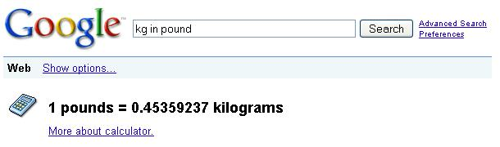

**Fig:** Online Unit Conversion using Google

Following are few other possible conversions. Click on these link to see the results.

* [km in mile](http://www.google.com/search?q=km%20in%20mile)
* [inch in feet](http://www.google.com/search?q=inch%20in%20feet)
* [acre in square feet](http://www.google.com/search?q=acre%20in%20square%20feet)
* [sec in ms](http://www.google.com/search?q=sec%20in%20ms)
* [kilobyte in byte](http://www.google.com/search?q=kilobyte%20in%20byte)
* You get the idea now. Try your own conversion and see how it works.

### 10. Money Conversion using Google

Following converts US Dollars in Euros (or) US Dollars in Rupees.

[USD in Euro](http://www.google.com/search?q=USD%20in%20Euro)

(or)

[USD in INR](http://www.google.com/search?q=USD%20in%20INR)

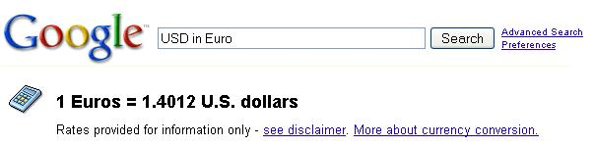

**Fig**: Currency Conversion Using Google

### 11. Searching within a Specific Website

You can search for a text in a specific website. The following example shows how to search only within our blog – www.thegeekstuff.com.

[examples site:www.thegeekstuff.com](http://www.google.com/search?q=examples%20site:www.thegeekstuff.com)

**Note:** There is no space between site: and the website address.

### 12. Google Search for a Given Keywords (both without and with sequence)

#### Basic Search for a Given Keywords – Without Sequence

The very basic feature of Google which everybody is using today is searching for pages which has the given text as:

[linux command line history examples](http://www.google.com/search?q=linux%20command%20line%20history%20examples)

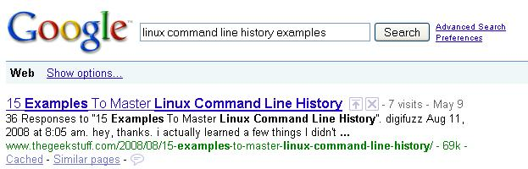

**Fig**: Basic Google Search for Keywords with no specific sequence

**Note:** Highlighted words are not in the order as we given in the search box.

#### Basic Search with Keywords In a Given Sequence

If you want Google to show only the pages which has the words in the given sequence, then double quote that search string as:

["guide to install php5 from source"](http://www.google.com/search?q=guide%20to%20install%20php5%20from%20source)

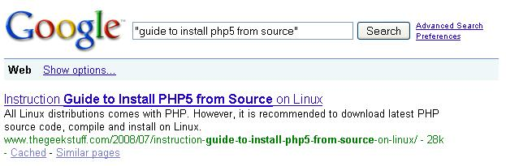

**Fig**: Basic Search for Keywords in a specific sequence

**Note:** Highlighted words are in the same order as we given in the search box.

### 13. Search Based on File Type

The following examples searches only the matching keywords inside a Power Point presentations. In the same way, you can search for the doc, pdf and other file types.

[linux introduction filetype:ppt](http://www.google.com/search?q=linux%20introduction%20filetype:ppt)

### 14. Google Advanced Search Page

If you are not able to remember some of the advanced search syntax mentioned in this article, then use the [Google Advanced search page](http://www.google.com/advanced_search?hl=en) as shown below.

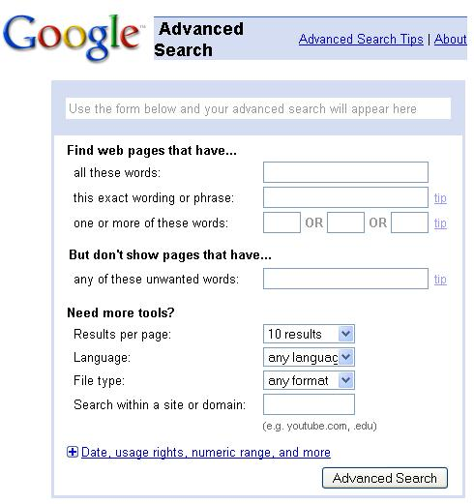  
**Fig:** [Google Advanced Search Page](http://www.google.com/advanced_search?hl=en)

### 15. Identify Local Weather for Any City in the World using Google

To see the current weather in Los Angeles do the following. Go-ahead and try this yourself for your local city and see how it works.

Syntax: weather PLACE

[weather Los Angeles](http://www.google.com/search?q=weather%20Los%20Angeles)

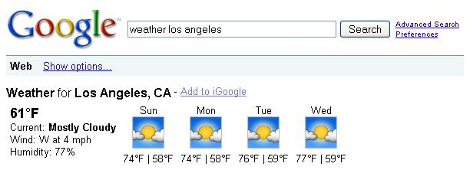

**Fig**: Find out current weather forecast of any worldwide city

> [Add your comment](http://www.thegeekstuff.com/2009/06/expertise-in-google-search/" \l "commentform)

### If you enjoyed this article, you might also like..

|  |  |
| --- | --- |
| 1. [50 Linux Sysadmin Tutorials](http://www.thegeekstuff.com/2010/12/50-unix-linux-sysadmin-tutorials/) 2. [50 Most Frequently Used Linux Commands (With Examples)](http://www.thegeekstuff.com/2010/11/50-linux-commands/) 3. [Top 25 Best Linux Performance Monitoring and Debugging Tools](http://www.thegeekstuff.com/2011/12/linux-performance-monitoring-tools/) 4. [Mommy, I found it! – 15 Practical Linux Find Command Examples](http://www.thegeekstuff.com/2009/03/15-practical-linux-find-command-examples/) 5. [Linux 101 Hacks 2nd Edition eBook](http://www.thegeekstuff.com/linux-101-hacks-ebook/) Linux 101 Hacks Book | * [Awk Introduction – 7 Awk Print Examples](http://www.thegeekstuff.com/2010/01/awk-introduction-tutorial-7-awk-print-examples/) * [Advanced Sed Substitution Examples](http://www.thegeekstuff.com/2009/10/unix-sed-tutorial-advanced-sed-substitution-examples/) * [8 Essential Vim Editor Navigation Fundamentals](http://www.thegeekstuff.com/2009/03/8-essential-vim-editor-navigation-fundamentals/) * [25 Most Frequently Used Linux IPTables Rules Examples](http://www.thegeekstuff.com/2011/06/iptables-rules-examples/) * [Turbocharge PuTTY with 12 Powerful Add-Ons](http://www.thegeekstuff.com/2008/08/turbocharge-putty-with-12-powerful-add-ons-software-for-geeks-3/) |

|  |  |  |  |
| --- | --- | --- | --- |
| [Bash 101 Hacks Book](http://www.thegeekstuff.com/bash-101-hacks-ebook/) | [Sed and Awk 101 Hacks Book](http://www.thegeekstuff.com/sed-awk-101-hacks-ebook/) | [Nagios Core 3 Book](http://www.thegeekstuff.com/nagios-core-ebook/) | [Vim 101 Hacks Book](http://www.thegeekstuff.com/vim-101-hacks-ebook/) |

Tagged as: [English dictionary](http://www.thegeekstuff.com/tag/english-dictionary/), [Find meaning of a word](http://www.thegeekstuff.com/tag/find-meaning-of-a-word/), [Google search tips and tricks](http://www.thegeekstuff.com/tag/google-search-tips-and-tricks/), [Mastering google search](http://www.thegeekstuff.com/tag/mastering-google-search/), [Money converter](http://www.thegeekstuff.com/tag/money-converter/),[Productivity Tips For Geeks](http://www.thegeekstuff.com/tag/productivity-tips-for-geeks/), [Time of a place](http://www.thegeekstuff.com/tag/time-of-a-place/), [Unit conversion tool](http://www.thegeekstuff.com/tag/unit-conversion-tool/), [Weather of a place](http://www.thegeekstuff.com/tag/weather-of-a-place/)

{ 34 comments… [add one](http://www.thegeekstuff.com/2009/06/expertise-in-google-search/" \l "commentform) }

* **beq** June 4, 2009, 12:23 pm

There is a translate tip too

Syntax: translate into

a. translate hola into english  
b. translate hello into spanish

[LINK](http://www.thegeekstuff.com/2009/06/expertise-in-google-search/" \l "comment-11185" \o "permalink to this comment)

* **beq** June 4, 2009, 12:24 pm

errata:  
Syntax error above…

Syntax: translate (word) into (language)

[LINK](http://www.thegeekstuff.com/2009/06/expertise-in-google-search/" \l "comment-11186" \o "permalink to this comment)

* **[David W.](http://info.birnamdesigns.com/)** June 4, 2009, 1:31 pm

Nice list, but #5 doesn’t have anything to do with Regex. Maybe you’re thinking of Boolean logic?

[LINK](http://www.thegeekstuff.com/2009/06/expertise-in-google-search/" \l "comment-11188" \o "permalink to this comment)

* **patek** June 4, 2009, 2:21 pm

related:website – searches similiar page

[LINK](http://www.thegeekstuff.com/2009/06/expertise-in-google-search/" \l "comment-11190" \o "permalink to this comment)

* **Tapas Mallick** June 4, 2009, 10:53 pm

We can use ‘+’ to get the result with the mentioned in the search output. e.g, kolkata +tapas

[LINK](http://www.thegeekstuff.com/2009/06/expertise-in-google-search/" \l "comment-11202" \o "permalink to this comment)

* **Jens** June 6, 2009, 10:28 am

Hm, the ‘time $CITY’ thing doesn’t work for me…

[LINK](http://www.thegeekstuff.com/2009/06/expertise-in-google-search/" \l "comment-11245" \o "permalink to this comment)

* **Ramesh Natarajan** June 6, 2009, 2:54 pm

**@Beq,**

Thanks for the translation tip. It works great.  
   
**@David,**

You are right. #5 is only about OR. I’ve changed the title accordingly. Thanks for pointing this out.  
   
**@Patek,**

Thanks for the tip about related website search.  
   
**@Tapas,**

Thanks for the tips about +. I tried with “ebooks +free” and it works great.  
   
**@Jens,**

Can you please tell me which city did you try? i.e the exact search term you used?

[LINK](http://www.thegeekstuff.com/2009/06/expertise-in-google-search/" \l "comment-11252" \o "permalink to this comment)

* **Jens** June 7, 2009, 3:54 am

@Ramesh

I used your example, LA, neither typing it nor using the direct link shows the time like in your screenshot, just normal search results. Other places doesn’t work too.

But the conversion things work, I’ve used them many times before, it’s just the time that doesn’t.  
Strange, maybe it has something to do with my german browser environment, I don’t know.  
But I get the same results in Opera, FF, Links and from other hosts it also fails.

[LINK](http://www.thegeekstuff.com/2009/06/expertise-in-google-search/" \l "comment-11263" \o "permalink to this comment)

* **Jens** June 7, 2009, 4:05 am

Okay, got it.  
If I change the prefered language in the browser settings from DE to EN and delete all cookies I get the desired result, but definitely not with DE, if I switch it from EN the other way.

[LINK](http://www.thegeekstuff.com/2009/06/expertise-in-google-search/" \l "comment-11264" \o "permalink to this comment)

* **Anonymous** June 8, 2009, 7:12 am

can i know where to type the syntax

[LINK](http://www.thegeekstuff.com/2009/06/expertise-in-google-search/" \l "comment-11286" \o "permalink to this comment)

* **[Pieter](http://haijen.com/)** June 8, 2009, 8:59 am

Ramesh,

I just want to thank you, very much, for the nice articles, time after time! Thank you!

Kind regards,  
Pieter

[LINK](http://www.thegeekstuff.com/2009/06/expertise-in-google-search/" \l "comment-11289" \o "permalink to this comment)

* **Ramesh Natarajan** June 14, 2009, 11:50 pm

**@Jens,**

Thanks for sharing information on how you fixed your problem with the Google search tip. I’m glad it worked out for you.  
   
**@Pieter,**

Thanks a lot for those kind words. The credit on this article goes to Sathiyamoorthy, who did a wonderful job in coming up with these tips.

[LINK](http://www.thegeekstuff.com/2009/06/expertise-in-google-search/" \l "comment-11498" \o "permalink to this comment)

* **Jens** June 15, 2009, 1:17 pm

It doesn’t really work out, if I have to change my default language environment to get a result for the time search. This is a fault at Googles side, in my eyes. When I use for the measurement conversions LANG doesn’t matter. Why should it matter on timezones? 

[LINK](http://www.thegeekstuff.com/2009/06/expertise-in-google-search/" \l "comment-11514" \o "permalink to this comment)

* **Shashi** June 29, 2009, 3:16 am

Nice tips… I was not aware of these..

[LINK](http://www.thegeekstuff.com/2009/06/expertise-in-google-search/" \l "comment-12061" \o "permalink to this comment)

* **Jai** July 9, 2009, 10:05 am

Great googling tips …. thanks for sharing

[LINK](http://www.thegeekstuff.com/2009/06/expertise-in-google-search/" \l "comment-12488" \o "permalink to this comment)

* **sireesha** December 24, 2009, 7:19 am

very nice tips  
thanx for sharing

[LINK](http://www.thegeekstuff.com/2009/06/expertise-in-google-search/" \l "comment-27186" \o "permalink to this comment)

* **Hassan Yousef** January 10, 2010, 6:28 pm

also those might be helpful  
search for bsd UNIX and linux specific inforamtion <http://www.google.com/bsd>  
search for linux specific inforamtion <http://www.google.com/linux>  
mac <http://www.google.com/mac/>  
microsoft <http://www.google.com/microsoft.html>

[LINK](http://www.thegeekstuff.com/2009/06/expertise-in-google-search/" \l "comment-29015" \o "permalink to this comment)

* **Gowri** March 4, 2010, 5:38 am

Very good tips

[LINK](http://www.thegeekstuff.com/2009/06/expertise-in-google-search/" \l "comment-37697" \o "permalink to this comment)

* **Rahul Mukherjee** August 19, 2010, 4:15 am

Please read info at <http://www.google.com/help/cheatsheet.html>

[LINK](http://www.thegeekstuff.com/2009/06/expertise-in-google-search/" \l "comment-59758" \o "permalink to this comment)

* **[Sean Benson](http://thesavingsnet.com/)** January 8, 2011, 2:19 pm

How do I use the Controle key to bring up Google search.  
At one time I could tap twice on the control key from almost anywhere i was working.  
I am using Windows 7 and Microsoft Office Home and Business 2010.Thanks Sean

[LINK](http://www.thegeekstuff.com/2009/06/expertise-in-google-search/" \l "comment-78060" \o "permalink to this comment)

* **[sunil sharma](http://www.google.com/microsoft.html)** March 17, 2011, 3:13 am

i is realy interesting and provides much information.  
Thanks…….

[LINK](http://www.thegeekstuff.com/2009/06/expertise-in-google-search/" \l "comment-92881" \o "permalink to this comment)

* **robinatw** June 23, 2011, 4:00 am

1、nagios ~tutorial  
2、vim editor * and replace examples  
3、bash examples OR programs  
4、examples site:www.thegeekstuff.com  
5、”guide to install php5 from source”  
6、linux introduction filetype:ppt

at lest, i think above key points is good for me..  
thanks for your post…

Robin

[LINK](http://www.thegeekstuff.com/2009/06/expertise-in-google-search/" \l "comment-114107" \o "permalink to this comment)

* **lalit** October 5, 2011, 7:00 am

Any one tell me why we use + operator for searching elements & what it does.

[LINK](http://www.thegeekstuff.com/2009/06/expertise-in-google-search/" \l "comment-130295" \o "permalink to this comment)

* **Chander** October 22, 2011, 10:42 pm

Awesome sir ……Thanks

[LINK](http://www.thegeekstuff.com/2009/06/expertise-in-google-search/" \l "comment-134384" \o "permalink to this comment)

* **Mallikarjuna Paitl** January 19, 2012, 5:18 pm

Cool..really helped lot in my daily activity.  
Thanks.

[LINK](http://www.thegeekstuff.com/2009/06/expertise-in-google-search/" \l "comment-181052" \o "permalink to this comment)

* **Riz** June 12, 2012, 10:32 pm

Thanks for the wonderful tutorial.  
About ‘Money Conversion using Google’, it also works with the amount I need to convert.  
e.g. 600 USD in INR  
It gives the calculated total amount. Very handy.

[LINK](http://www.thegeekstuff.com/2009/06/expertise-in-google-search/" \l "comment-251300" \o "permalink to this comment)

* **Tipu (TStar)** September 17, 2012, 11:42 am

Awesum…. This are really helpful…thanks for this …

[LINK](http://www.thegeekstuff.com/2009/06/expertise-in-google-search/" \l "comment-308872" \o "permalink to this comment)

* **sunil** October 30, 2012, 11:24 pm

Thanks a ton…i can get results faster than before (y)

[LINK](http://www.thegeekstuff.com/2009/06/expertise-in-google-search/" \l "comment-358897" \o "permalink to this comment)

* **Arjun Sanapati** November 1, 2012, 1:31 pm

Tips are really helpful.

[LINK](http://www.thegeekstuff.com/2009/06/expertise-in-google-search/" \l "comment-361136" \o "permalink to this comment)

* **sam** April 25, 2013, 2:00 am

oh!my god, mind blowing search tips brother. i am thankful to u.

[LINK](http://www.thegeekstuff.com/2009/06/expertise-in-google-search/" \l "comment-712262" \o "permalink to this comment)

* **Beckett** September 3, 2013, 12:33 pm

Hey, this is well organized page. Thanks for putting it up.

One question. I’ve been noticing that when excluding words in Google I find that sometimes the amount of results actually increases! Do you know why that could happen. I can’t figure it out for the life of me.

Example. “Jaguar” (208 million results)..”Jaguar -cars” (244 million).

Thanks B

[LINK](http://www.thegeekstuff.com/2009/06/expertise-in-google-search/" \l "comment-914974" \o "permalink to this comment)